TASK 03
#include <iostream>
#include <list>
using namespace std;

#define SIZE 10

class Hash {
list<int> table[SIZE];
public:
int hashFunction(int key) {
return key % SIZE;
}

// push_back: Adds an element to the end of the list
void insert(int key) {
int index = hashFunction(key);
table[index].push_back(key);
}

// begin/end: Get iterators to start/end of the list
// erase: Removes the element at the given iterator position
void deleteKey(int key) {
int index = hashFunction(key);
auto& chain = table[index];
bool found = false;
for (auto node = chain.begin(); node != chain.end(); ++node) {
if (*node == key) {
chain.erase(node);
cout << "Key " << key << " deleted from the hash table." << endl;
found = true;
break;
}
}
if (!found) {
cout << "Key " << key << " not found for deletion." << endl;
}
}

// begin/end: Used to iterate through the list
void search(int key) {
int index = hashFunction(key);
auto& chain = table[index];
bool found = false;
for (auto node = chain.begin(); node != chain.end(); ++node) {
if (*node == key) {
cout << "Key " << key << " found in the hash table." << endl;
found = true;
break;
}
}
if (!found) {
cout << "Key " << key << " not found in the hash table." << endl;
}
}

// Range-based for: Iterates through all elements in the list
void display() {
for (int i = 0; i < SIZE; i++) {
cout << i << " -> ";
for (int val : table[i]) {
cout << val << " -> ";
}
cout << "nullptr" << endl;
}
}
};

int main() {
Hash hashTable;

hashTable.insert(10);
hashTable.insert(22);
hashTable.insert(15);
hashTable.insert(25);
hashTable.insert(30);

cout << "Hash Table:" << endl;
hashTable.display();

hashTable.search(15);
hashTable.search(99);

hashTable.deleteKey(22);
hashTable.deleteKey(99);

cout << endl;
cout << "Hash Table after deletions:" << endl;
hashTable.display();

return 0;
}

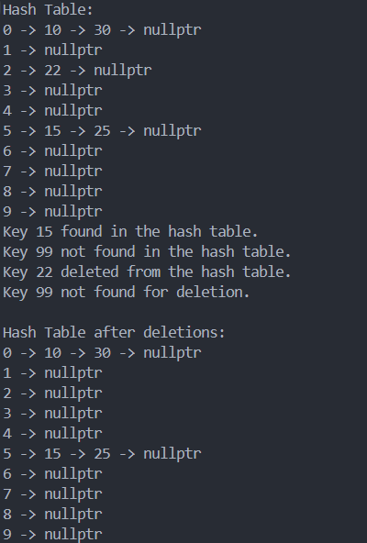

TASK 04
#include <iostream>
using namespace std;

#define SIZE 10

class HashTable {
int *table, count;
public:
HashTable() {
table = new int(SIZE);
count = 0;
for (int i = 0; i < SIZE; i++) {
table[i] = -1;
}
}

int hashFunction(int key) {
return key % SIZE;
}

void insert(int key) {
int index = hashFunction(key);
while (table[index] != -1) {
index = (index + 1) % SIZE;
}
table[index] = key;
count++;
}

void display() {
bool first = true;
for (int i = 0; i < SIZE; i++) {
if (table[i] != -1) {
if (!first) {
cout << " -> ";
}
cout << table[i];
first = false;
}
}
cout << endl;
}

void Search(int key) {
int index = hashFunction(key);
int startIndex = index;
while (table[index] != -1) {
if (table[index] == key) {
cout << key << " found" << endl;
return;
}
index = (index + 1) % SIZE;
if (index == startIndex) {
break;
}
}
cout << key << " not found" << endl;
}

void remove(int key) {
int index = hashFunction(key);
int startIndex = index;
while (table[index] != -1) {
if (table[index] == key) {
table[index] = -1;
count--;
cout << "Removing " << key << endl;
return;
}
index = (index + 1) % SIZE;
if (index == startIndex) {
cout << "Key " << key << " not found" << endl;
break;
}
}
}
};

int main() {
HashTable ht;
ht.insert(1);
ht.insert(3);
ht.insert(4);
ht.insert(5);
ht.insert(7);
ht.display();

ht.remove(4);
ht.display();

ht.Search(5);
ht.Search(6);
return 0;
}
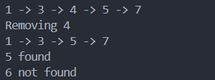

TASK 05

#include <iostream>
using namespace std;

const int SIZE = 1009;
struct Pair {
int a, b;
bool valid;
Pair() : a(0), b(0), valid(false) {}
};

int hashFunc(int sum) {
return (sum % SIZE + SIZE) % SIZE;
}

void findPairsWithEqualSum(const int arr[], int n) {
Pair hashTable[SIZE];
for (int i = 0; i < n; ++i) {
for (int j = i + 1; j < n; ++j) {
int sum = arr[i] + arr[j];
int idx = hashFunc(sum);
while (hashTable[idx].valid && (hashTable[idx].a + hashTable[idx].b != sum)) {
idx = (idx + 1) % SIZE;
}
if (hashTable[idx].valid) {
if (hashTable[idx].a != arr[i] && hashTable[idx].a != arr[j] && hashTable[idx].b != arr[i] && hashTable[idx].b != arr[j]) {
cout << "(" << hashTable[idx].a << ", " << hashTable[idx].b << ") and (" << arr[i] << ", " << arr[j] << ")\n";
return;
}
} else {
hashTable[idx].a = arr[i];
hashTable[idx].b = arr[j];
hashTable[idx].valid = true;
}
}
}
cout << "No pairs found\n";
}

int main() {
int arr1[] = {3, 4, 7, 1, 2, 9, 8};
int n1 = sizeof(arr1) / sizeof(arr1[0]);
findPairsWithEqualSum(arr1, n1);

int arr2[] = {3, 4, 7, 1, 12, 9};
int n2 = sizeof(arr2) / sizeof(arr2[0]);
findPairsWithEqualSum(arr2, n2);

int arr3[] = {65, 30, 7, 90, 1, 9, 8};
int n3 = sizeof(arr3) / sizeof(arr3[0]);
findPairsWithEqualSum(arr3, n3);
}

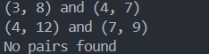

TASK 06
#include <iostream>
using namespace std;

#define SIZE 15

class StudentRecord {
public:
int rollNo;
string name;
bool isOccupied;
StudentRecord() : rollNo(-1), name(""), isOccupied(false) {}
};

class StudentHashTable {
StudentRecord table[SIZE];
public:
StudentHashTable() {}

int hashFunction(int key) {
return key % SIZE;
}

void insert(int rollNo, string name) {
int index = hashFunction(rollNo);
int attempt = 0;
while (attempt < SIZE) {
int probeIndex = (index + attempt * attempt) % SIZE;
if (!table[probeIndex].isOccupied) {
table[probeIndex].rollNo = rollNo;
table[probeIndex].name = name;
table[probeIndex].isOccupied = true;
cout << "Inserting " << rollNo << " at index " << probeIndex << endl;
return;
}
attempt++;
}
cout << "Hash table is full, cannot insert " << rollNo << endl;
}

void Search(int rollNo) {
int index = hashFunction(rollNo);
int attempt = 0;
while (attempt < SIZE) {
int probeIndex = (index + attempt * attempt) % SIZE;
if (table[probeIndex].isOccupied && table[probeIndex].rollNo == rollNo) {
cout << "Student found: " << table[probeIndex].name << endl;
return;
}
if (!table[probeIndex].isOccupied){
break;
}
attempt++;
}
cout << "Record not found" << endl;
}
};

int main() {
StudentHashTable sht;
sht.insert(101, "Omer");
sht.insert(116, "Ali");
sht.insert(131, "Ahmed");
sht.insert(146, "Sara");

sht.Search(131);
sht.Search(200);

return 0;
}
